DATE: 03.01.2020
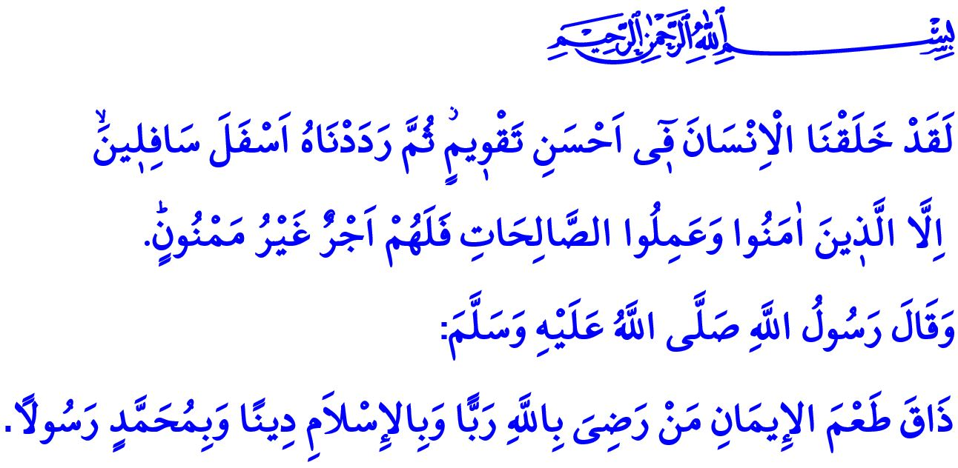
HUMAN, FAITH AND LIFE
Honorable Muslims!
In the verse I have recited, Allah the Almighty (swt) states, “We have indeed created man in the best of moulds, then do We abase him (to be) the lowest of the low, Except such as believe and do righteous deeds: for they shall have a reward unfailing.”
The Prophet Muhammad (saw) said in the hadith I have read, “Those who are content with Allah as their Lord, with Islam as their religion, and with Muhammad as their Prophet has found the taste of faith (iman).”
Dear Believers!
Allah the Exalted (swt), the one and only Owner of the earth and the heavens, has created human in a perfect form. He has bestowed upon them a mind to distinguish between right and wrong, and a conscience to guide them on the path to goodness. As a strong and conscious being with free will and sense of responsibility, human is the treasure of the universe.
Allah the Almighty (swt), who has created human from nothing, bestows upon them blessings to feed them, and protects them, and wants them to have faith and do good deeds. The reason for the existence of humans is to bear the amanah as a servant, and to make the world a peaceful, fair, and livable home for humanity.
Dear Muslims!
Humankind has quite superior qualities, privileged power and abilities. They can intend to do good and manage life in a good way thanks to those qualities. But they can also desire evil and spread cruelty around the world. As they can build a happy world with their patient, determined, peaceful and fair attitudes, they can also endanger both themselves and their surroundings with their ignorant, selfish, ambitious, hasty, and ungrateful attitudes.
Therefore, our Lord (swt) never gives rein to human. He has not abandoned the universe after creating it. Allah (swt) always sees, looks after, and manages. He never leaves human alone, deprived of blessings, and helpless in the life. He is with us each moment; closer to us than our jugular vein. The greatest support of Allah the Almighty (swt) to us is the guidance He gives us through His Prophet and His Book.
Dear Believers!
The divine law that is sent by Allah (swt) to humanity as a guide, a light of life, and a source of salvation which invites men of understanding to accept the guide of salvation brought by our Prophet is called religion. Religion came into being with the first human, and will exist until the last day. We all know as believers who came together in this holy masjid in this hour of Friday that “The Religion before Allah is Islam.” All humans until the Day of Resurrection are obliged to be one of the Ummah of our Beloved Prophet (saw), and to respond to his invitation. Because, “If anyone desires a religion other than Islam, never will it be accepted of him; and in the Hereafter he will be in the ranks of those who have lost (all spiritual good).”
Religion is the soundest source of knowledge where people can find answers to their questions, and solutions to their problems. Those who believe by responding the invitation of the religion have given the best decision of their life. They have been honored by becoming Muslims. They turned to Allah (swt) with their own choice voluntarily without being forced. They have sincerely accepted the commands and prohibitions of Him. From that moment on, they are expected to fulfill the requirements of their faith, and to live as a believer does.
Dear Muslims!
Islam is a unique system of faith, worship, and morality.  Taking the kalimah al-shahadah by uttering these words is to open the gate to faith, hope, and happiness both for the world and the Hereafter. Those who enter through this gate perform their prayers regularly and meticulously. Prayer (salah) is the pillar of our religion and the light of our hearts. They fast zestfully and patiently. Fasting is the shield protecting us from being captive to our nafs and to Satan. They pay their alms (zakat) sincerely and kindly. Zakat is the bridge turning the ephemeral worldly belongings into eternal gain and brotherhood. They fulfill their duty of hajj devotedly and submissively. Hajj is the holy journey which makes people meet with themselves and other faithful hearts around the Ka’bah.
The aim of worship in Islam is to enable people to establish a sound communication with themselves, with Allah (swt), and with all other beings. For this reason, each worship requires to be completed with good morality. A way of life befitting to Muslims can be lived by observing the moral principles as well as the worships. It is an indispensable requirement of being Muslim to observe the rights, to not let cruelty and oppression, to spread mercy and prevent violence. Making life blessed with justice, honesty, humbleness and generosity is the essential of a Muslim's personality. Let us not forget that those whose minds are with the truth, whose hearts are with goodness and whose possibilities are with beneficial deeds will fulfill the requirement of their faith.
May the Almighty Allah (swt) accept all the donations we have made up to now and we will make from now on.

Tin, 95/4-6.
Muslim, Iman, 56.
Al-i ‘Imran, 3/19.
Al-i ‘Imran, 3/85. General Directorate of Religious Services

